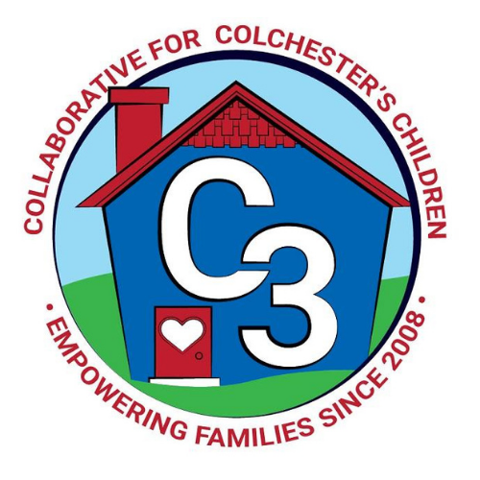
Colchester School Readiness Council
April 28, 2021
Location: Google Meet
Time: 5:30 – 7:00 p.m.

Meeting Minutes

Attendance: Jennifer Rummel, Kristina Swain, Laurie Buyniski, Judy O’Meara, Cindy Praisner, Jessica Morozowich, Lindsay Therian, Nicole Sargent, Krystin Lattarula

McKinney-Vento Homeless Update: No update.

Current SR Classroom Status: C. Praisner updated members, CECP has 21/22 Part-day spaces filled, CASTLE has 9/9 School-day spaces filled, one student attended Part-day for one month.

SR Classroom Monitoring: Next CLASS visit to be scheduled with J. Lenares for end of May.

SR Budget Update: C. Praisner reviewed the budget to date. Castle confirming quote for playground mulch $1200.

SR RFP Timeline:
- May 6th BOS approval of the application
- May 11th BOE Approval of the application
- May 16th Submit to the state

QE Funding for FY22: C. Praisner reviewed the QE budget draft which includes 3 PD workshops on the topics of early math, diverse learners and data collection. Two will be offered by EASTCONN, ACES will offer workshop on data. Budget also includes compensation for staff to attend, paras eligible, CASTLE teachers. Remaining funds listed under PD materials in case revisions are needed. CECP wants to continue using ESGI. Monitoring will be done with CLASS and TPOT, funds are available to offer monitoring for classrooms outside of SR, including community programs. J. Lenares and C. Praisner will maintain CLASS certification.

Hardship Request: Council members reviewed and approved a hardship request.

Space Allocations: CECP plans to reassign all 22 Part-day SR spaces to 16 School day spaces. Plans to offer transportation and before & aftercare for families. Will offer 2 lottery spaces in the classroom for a total of 18 students. This change will bring total School day spaces for Colchester to 25. If the School day spaces are not filled, may have the option to shift back some spaces to Part-day.

SR RFP Approval: Council approved plan for space reallocation and will move forward with grant application, contingent upon approval by the BOE on May 11th. Shift in spaces will reduce grant by $3k in tuition and $150 in Admin dollars.

Non-Resident Policy: Council discussed potentially allowing non-residents to fill SR slots if not filled by Colchester residents. Council agreed to grandfather one student at CASTLE who is moving out of the district to maintain consistency for the student in the upcoming year. Council plans to reconvene and discuss further if slots are remaining by August but priority will continue to go to Colchester residents.

2020-2021 Meeting Dates
May 6, 2021 (in needed)

Submitted by:

Laurie Buyniski, Assistant to the Coordinator

